**Module 3 Assignment – Data Exchange and Data Formats**

Sasanka Vepakomma

Ira A. Fulton Schools of Engineering, Arizona State University

IFT 598: Middleware Programming & Database Security

Prof. Dinesh Sthapit

Due: Sept 24, 2022

**Module 3 Assignment – Data Exchange and Data Formats**

Commands/Concepts learned:

* fetch import // one can fetch data by calling certain APIs as an input to fetch
* “type”:”module” // one needs to add this to package.json to run the methods of one file in another

Screenshots:

Video 1:

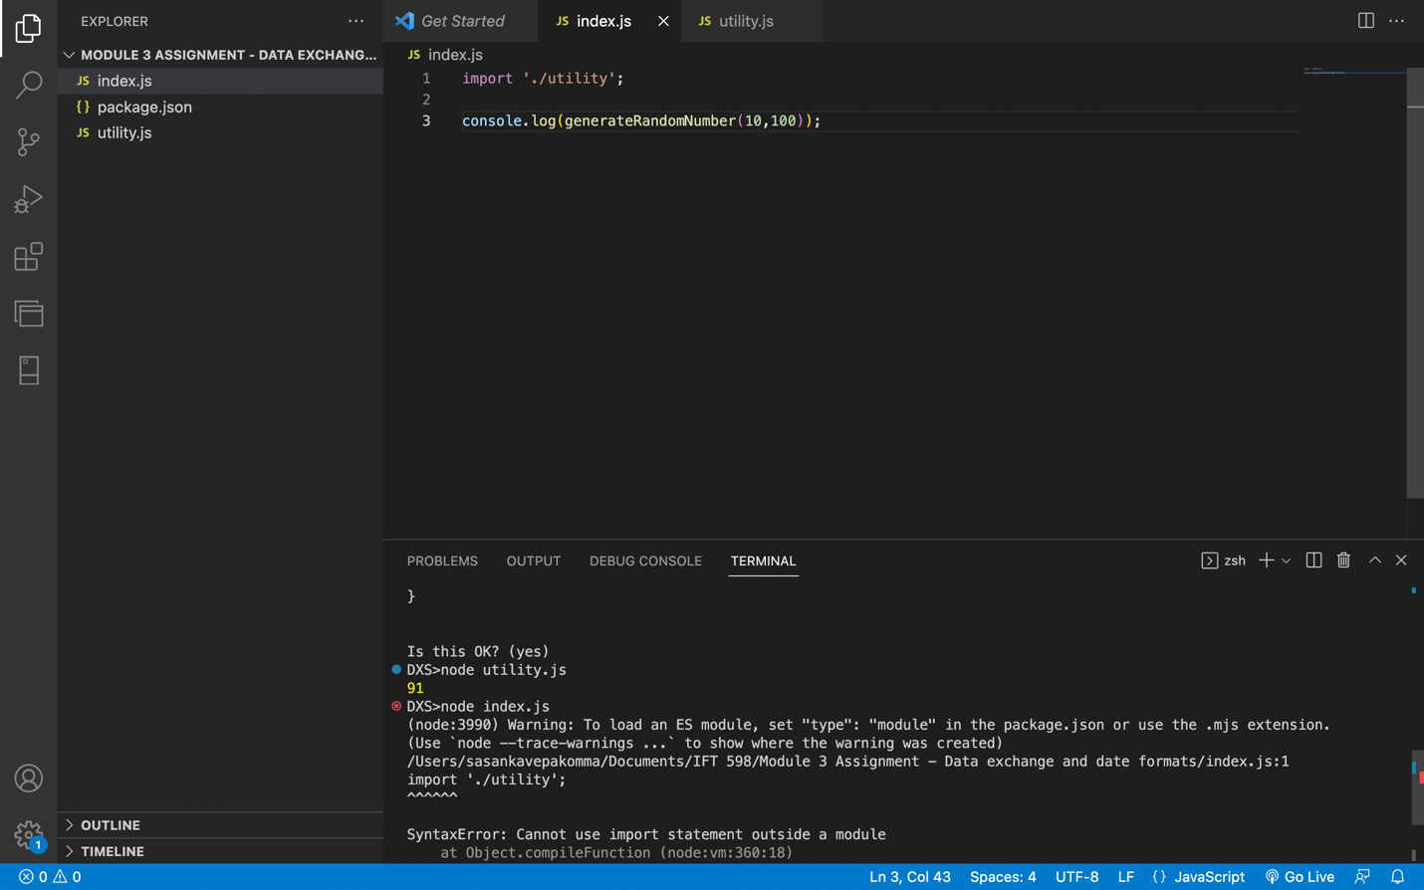

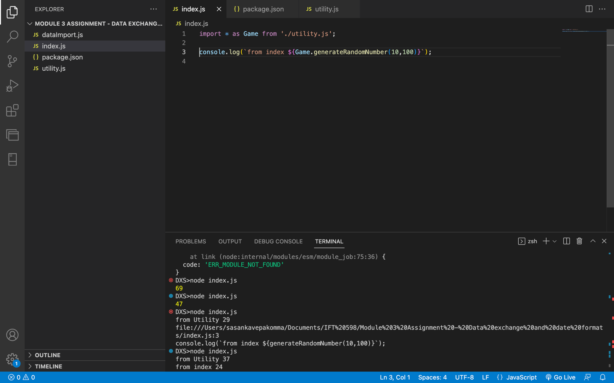

Video 2:

Video 3:

Video 4:

GitHub link:

<https://github.com/vsasanka/IFT598MiddlewareProg-DBSecurity/tree/main/module%203%20assignment>